**YEAR 12 CHEMISTRY – ATCHE (DRAFT 1)**

**/66**

**TEST 1**

**Reaction Rates and Equilibrium 2021**

**ANSWERS**

**MULTIPLE CHOICE:**

|  |  |  |  |  |  |  |  |  |  |
| --- | --- | --- | --- | --- | --- | --- | --- | --- | --- |
| **Q1** | **Q2** | **Q3** | **Q4** | **Q5** | **Q6** | **Q7** | **Q8** | **Q9** | **Q10** |
| **A** | **C** | **C** | **D** | **C** | **B** | **A** | **A** | **A** | **B** |

|  |  |  |  |  |
| --- | --- | --- | --- | --- |
| **Q11 ?** | **Q12** | **Q13** | **Q14** | **Q15** |
| **B** | **D** | **B** | **B** | **C** |

**PART B – SHORT ANSWER & WRITTEN QUESTIONS (51 Marks)**

Answer **ALL** the questions in the spaces provided below and read the questions carefully. Marks allocated for each question is shown next to it. Note that not all questions carry equal number of marks. **(ANSWERS BOLDED)**

**(11marks)**

Q16. As a first step in the manufacture of nitric acid it has been suggested that nitrogen monoxide gas , NO, can be formed from nitrogen gas and oxygen gas in a revsible reaction.

(a) Write a balanced equation, including states of matter, for the reaction and deduce an expression for the equilibrium constant (K)

Equation: **N2(g) + O2(g)  2NO (g)** (1 mark)

**[ NO ]2**

**K = _____________**

**[N2] [O2]**

(1 mark)

b) The sketch graph below shows how the K value for the reaction changes with

temperature

K

Temperature

(c) Use the graph above to deduce whether the reaction is endothermic or

exothermic (1 mark)

**Reaction is Endothermic (+∆H)**

Explain your answer using Le Chatelier’s Principle (LCP) (2 marks)

**An increase in temperature favours the endothermic reaction.(1)**

**As K increases it means product formation is favoured. (1)**

**Therefore reaction as written must be endothermic (1) (any 2 for 2 mks)**

(d) The value of K for this reaction is 1.00 x 10-5  at 1500 kelvin . Explain the significance of this value for an industrial chemist interested in producing nitrogen monoxide gas by the direct combination of the starting elements. (2 marks)

**K value quite low 1.00 x 10 -5 @ 1500 K (1) hence yield will be low as well (1)**

**Low yield at high temperature and high cost does not justify the conditions employed economically. (1) (any 2 for 2 marks)**

(e) When cooled, nitrogen monoxide reacts with oxygen gas to form gaseous nitrogen dioxide gas.

(i) Write a balanced chemical equation for this reaction. (1 mark)

**2NO(g) + O2(g)  2 NO2(g) (1)**

(ii) State how an increase in **pressure** would change the position of the equilibrium and the change the value of the equilibrium constant (K).

Change in equilibrium position : (1 mark)

**Equilibrium position shifts from left to right to favour forward direction. (1)**

Change in the equilibrium constant: ( 2 marks)

**K value will remain constant (2)**

Q17. **(8 marks)**

Calcium hydroxide is slightly soluble in water. The equilibrium established when solid Ca(OH)2 is in contact with saturated solution is represented below:

**Ca(OH)2 (s) ⮀ Ca 2+ (aq) + 2OH – (aq)**

An equilibrium mixture of solid calcium hydroxide and its saturated solution is prepared. Four test tubes are set up, each containing some of the equilibrium mixture – a little white solid under a colourless solution. Each of the tubes is treated as described below. In each case state how the equilibrium will shift, and what will be observed.

**N.B. 1 mark per box for correct answers**



|  |  |  |
| --- | --- | --- |
| What is done | How the equilibrium shifts. Write ‘⭢’, ‘⭠’, or ‘no change’ | What is observed. Give the complete observations. |
| A little concentrated hydrochloric acid is added  to the first tube |  | **Amount of white solid decreases** |
| A little concentrated  (3 mol L – 1) calcium chloride is added to the second tube |  | **Amount of white solid increases.** |
| A little solid calcium hydroxide is added to the third tube and the mixture shaken | **NO CHANGE** | **Added** **Ca(OH)2 (s) settles into the bottom of the container**    **Or**  **NO visible reaction** |
| A little solid sodium chloride is added to the fourth tube and the mixture shaken | **NO CHANGE** | White solid dissolves  **NO other visible reaction** |

**Q18 (12 MARKS)**

Space X is an American company that wants to send humans to Mars to explore the planet and establish a colony. One big challenge of this mission is to find a reliable fuel source away from Earth.

The company plans to solve this problem by using the Sabatier reaction. The equation for the reaction is:

CO2 (g) + 4H2(g) **⇌** CH4 (g) + 2H2O (g) ∆H = -165 kJ/mole

The resulting methane gas could be used as rocket fuel. Tne yield in the Sabatier reaction. **N.B. 1 mark for each underlined or circled answer**

|  |  |
| --- | --- |
| **Imposed Change** | effect on methane **yield** (circle your answer) |
| (i) a suitable catalyst is added | increase decrease **no effect** |
| (ii) the volume of the reaction vessel is increased | increase **decrease** no effect |
| (iii) the temperature is increased | increase **decrease** no effect |
| (iv) methane is removed as soon as it is formed using a special valve | **increase** decrease no effect |
| (v) the partial pressure of carbon dioxide is decreased | increase  **decrease**  no effect |

(5 marks)

(a) Graphs can be drawn to show the effects of imposed changes on equilibrium systems. The graph below shows the effects of some changes that might be made to the reacting system in a flexible vessel.

CO2 (g) + 4H2(g) **⇌** CH4 (g) + 2H2O (g) ∆H = -165 kJ/mole

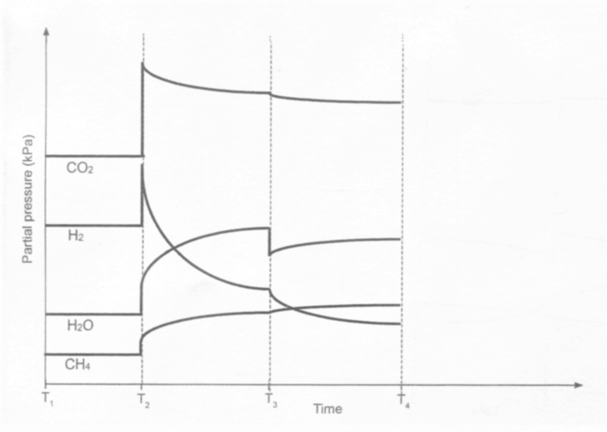

1

2

1

4

By referencing the above graph, answer the following questions:

(b) What was happening at T1? (1 mark)

**SYSTEM AT CHEMICAL EQUILIBRIUM (1)**

(c) Identify the imposed change at each time in the table below. (2 marks)

|  |  |
| --- | --- |
| **Time** | **Change imposed on the system** |
| T2 | **System (V) decreased or Pressure (P) increased (1)** |
| T3 | **Steam - H2O(g) - removed (1)** |

(d) The temperature of the reaction vessel was decreased at T4. Sketch,neatly, on

the graph above to show how this affected the partial pressure of all species present.

Include any changes to scale and continue until a new equilibrium is established. (4 marks)

**1 mark for each neatly drawn correct line or answer to max of 4 marks**

**-1/2 mk for each; incorrect stoich ratio; incorrect shape; eq’m reached for each line but NOT all lines.**

**Q19 (14 MARKS)**

The two different coloured complex ions, [Co(H2O6]2+(aq) and [CoCl4]2- , exist together in equilibrium in solution in the presence of chloride ions. The equation is as shown below:

[Co(H2O)6]2+ (aq) + 4Cl- (aq)⇌ [CoCl4(aq) ]2- + 6 H2O(l)

Pink blue

An experiment was conducted to investigate the effects of equilibrium position by imposing a series of changes on the system. The shift in equilibrium position can be indicated by any colour change of the solution.

**COLOUR chart**

|  |  |
| --- | --- |
| **Species** | **colour** |
| [Co(H2O)6]2+ (aq) | Pink |
| [CoCl4(aq) ]2- | Blue |
| Initial equilibrium mixture | Purple |

After a 3.00 mL sample of the initial equilibrium was placed in each of these test tubes, changes to each system were made by adding a different substance, as indicated in the table below.

|  |  |
| --- | --- |
| Test tube | Substance added to the test tube |
| 1. | 1 – 2 drops of distilled water |
| 2. | 2 – 5 drops of 10 mol/L hydrochloric acid |
| 3. | 2 - 5 drops of 0.250 mol/L AgNO3(aq) solution |

19 (a) complete the table below by predicting the:

* Change in concentration, if any, of each of the ions in solution compared to the initial solution, after a new equilibrium position is reached.
* Colour change, if any, that takes place from the initial purple- coloured solution

|  |  |  |
| --- | --- | --- |
| Addition to the test tube | change in concentration from initial concentration to final equilibrium.  **(increase, decrease, unchanged**) | Colour favoured  **(pink, blue or unchanged)** |
|  | [Co(H2O)6]2+ [ Cl-] [CoCl4 ]2- |  |
| 1. add water H2O (l) | . **decrease** **decrease** **decrease** | **pink** |
| 2. add  HCl (aq) | **decrease**  **increase**  **increase** | **blue** |
| 3. add AgNO3 (aq) | **increase**  **decrease**  **decrease** | **pink** |



(6 marks)

19 (b) Other than a colour change, what else should be observed in test tube 3?

(1 mark)

**An insoluble white ppt (1)**

**(If only: “AgCl is precipitated” 0 mark – not an observation)**

19 (c) Using Collision Theory, explain your predicted observations when hydrochloric acid is added to test tube 2. (4 marks)

**Adding HCl(aq) increases [ Cl-] and the number of effective collisions between**

**[ Co(H2O)6] 2+ and Cl- increases (1)**

**Rate of forward (Rf) reaction increases relative to the reverse reaction ( Rr) and therefore the eqm shifts to the right (1)**

**This leads to increased [ blue CoCl4 ] 2-  and lower [ Co(H2O)6] 2+ ion (1)**

**Hence the solution looks more blue or darker blue (1)**

Another experiment was conducted to investigate the effect that changing the temperature had on the equilibrium mixture. When 3.00 mL of original equilibrium mixture was placed in a test tube and then in an ice bath bath, the solution became pink.

19 (d) Determine whether the forward reaction, as shown by the equation below, is endothermic or endothermic. Use Le Chatelier’s Principle to justify your answer.

(3 marks)

[Co(H2O)6]2+ (aq) + 4Cl- (aq)⇌ [CoCl4(aq) ]2- + 6 H2O(l)

Pink blue

**Decreasing temperature removes heat from the system (1)**

**LCP states that if a chemical system at equilibrium is disturbed then the system will react to partially counteract the imposed change (1)**

**In this case favouring the exothermic reaction from right to left (1)**

**Therefore the reaction as written from left to right is endothermic**

**(1 )**

( any 3 for three marks)

**Q20 (6 MARKS)**

Ocean acidification results from carbon dioxde dissolving in water and an equilibrium being established between water and carbon dioxide to carbonic acid, H2CO3

(a) write a balanced equation for this equilibrium.

**CO2(g) + H2O (l) ⇌ H2CO3(aq) (2)**

(b) The formation of carbonic acid leads to an increase in hydronium ion (H3O+) concentration in water. Show the equilibrium that results in the formation of hydronium ions when carbonic acid reacts with water. (1 mark)

**H2CO3(aq) + H2O (l) ⇌ H3O+(aq) + HCO3 -1(aq) (1)**

(c) State one problem ocean acidification is causing for marine invertebrates (organisms). Explain how this problem arises and support your answer with an appropriate balanced equation. (3 marks)

**Problem: Marine invertebrates such as corals are thinning their exterior hard shelled exo-skeletons made out of CaCO3 (s)**

**By increasing the [ H3O+(aq)] ion ocean pH drops as more [ H3O+(aq)] ions are available to react with the CO32-(aq) ions to form HCO3 -1(aq) ions which in turn lowers the [ CO32-(aq)] ions . Due to the Eqm below: (1)**

**Ca2+(aq) + [CO32-](aq) ⇌ CaCO3(s) (1)**

**As [CO32-(aq) ] decreases the eqm shifts from right to left causing the thinning of the hard exterior skeleton as solid CaCO3 dissolves (1)**